Downtown School Dispatch
May 26, 2015
For information about parking and accessibility to the building for the disabled,
please contact John Johnson at 242-8422.
For sign or language interpreters, please call 242-7714.

From the Principal’s Desk . . .

Downtown School 2015-16 Calendar
The Downtown School Year Round Calendar (attached) has been approved by the Iowa Department of Education.

Thank you for your lobbying efforts for our calendar and for your continued lobbying for other school-related legislation.

Although this approval is something we have all been waiting for, please read beyond this first item. There is a lot of interesting information in the next few pages.

Teacher Appreciation Week
Teacher Appreciation Week was an absolutely wonderful week for the DTS teachers and staff.

Thank you for a wonderful week of food and beverages for Teacher Appreciation Week. Thank you to those who planned and organized the activities, the banner, to the numerous parents who brought in wonderful meals and snacks that week, to those who helped with clean-up, etc.

Our diets all went out the window that week!

“Bids for Kids”
Wow! Another fun and exciting evening!

The DTS Silent Auction (this year’s “Bids for Kids”) is always an event for which to look forward. As with all of our successful activities, one or two individuals cannot do it alone. There were a number of parents who donated numerous hours contacting parents and other volunteers, gathering donations, designing and printing flyers and e-mail reminders, transporting and setting up donated items, etc. I will not attempt to list individual names for fear of unintentionally leaving someone off the list.

In addition to those who helped organize and work behind the scenes, parents and other guests opened their checkbooks and bid quite generously, maybe even a little extravagantly, for many, many auction items that evening.

Mrs. Jamie Seitz was a great Master of Ceremonies! Watch out Jimmy Fallen.
Mr. Brian Congdon provided wonderful musical entertainment!
Mr. Don Short and Ms. Julie Lehman for opening up West End Architectural Salvage.

Mrs. Smith and I were surprised, overwhelmed and very touched by the nice comments and presentation that evening. We love our sculptures!

Registration Day for 2015-16
Although the district is providing an opportunity for on-line registration this year (more information to follow), we will still have our usual “Registration Day” activities from 1:00-7:00pm on Thursday, July 30.

Class lists will be posted that day and a small packet of information for each family which will be available. Packets will include:
- Suggested Supply List
- Contact Information – a copy of this year’s contact information. We will ask parents to review this information and let us know of any changes we might need to make.
- Media Consent
- PTA Packet – Opportunity to PTA, donate to the student activity fund, purchase a portfolio notebooks, if child is entering a new team.

This is also a nice day to sign up for committees and meet other parents!
Changes at DTS for 2015-16
Ms. Clark will be transitioning from her .5 Teaching and .5 Instructional Coaching position to a new full-time TLC Coaching position at the DTS. This new coaching position is supported by the district and is part of an effort to implement the Marzano Instructional Framework in the DMPS. This framework ties in very closely and supports the DTS philosophy.

Please welcome Mrs. Deb Croft to the Downtown School. Mrs. Croft will be our .5 Reading and Math Interventionist and Coach and will share the other half of her position at Studebaker Elementary School. Mrs. Croft comes to us from Capital View Elementary School, where she had a similar position. I had the opportunity to work with Mrs. Croft years ago at Park Avenue Elementary School. She is an excellent educator.

Mrs. Booth has accepted a position as a district-wide Induction Coach. She will be providing mentoring assistance to first and second year teachers throughout the Des Moines Public Schools. Mrs. Booth will certainly be missed at the Downtown School. She has helped numerous children get a positive start to their education.

Please welcome Ms. Stephanie Hubka to the Downtown School. Ms. Hubka comes to us from Cattell Elementary School, where she has been a K-3 Interventionist. She already has some experience at the DTS. She served as Ms. Buckner’s long-term substitute when she was out for maternity leave at the beginning of this school year. Ms. Hubka and Mrs.Mathews will become teaching partners for next school year.

Foundations of DTS Remain Solid
The foundations of the Downtown School remain solid!

Small class sizes, an integrated curriculum, multi-age classrooms, active and experience-based learning, authentic assessments, portfolios, student-led conferences, educational profiles, a year-round calendar and most importantly, active parental involvement continue to be the foundations of the Downtown School.

We will also continue to have an extremely professional and dedicated staff for the cutest children in the country.

Our Vision
Based on current research and proven educational practices,
which are responsive to the changing needs of the community,
the Downtown School will provide a total multi-age elementary experience.

Our Mission
The Downtown School, in collaboration with parents and business community,
will provide a diverse, experience-based learning environment that ensures each child’s success.

Iowa Assessments
Children in grades 3-5 take the Iowa Assessments (formerly the Iowa Test of Basic Skills) each year. Individual results will be sent home with the children on Wednesday, May 27.

Iowa Assessments provide a snapshot of how a child does on a particular test on a particular day. Although our nationally-normed, performance-based tests are a more authentic assessment of each child’s achievement, the Iowa Assessments provide a comparison with other children and other schools throughout the nation. Our building proficiency rates, from 2006-07 to the present, are listed below. Please note the positive trends, in each of the areas tested, from one year to the next as children progress through the grade levels.

There is a consistent increase in proficiency levels demonstrated by these cohort groups of students as they progress from 3rd to 4th grade and from 4th to 5th grade . . . even from 5th to 6th grade during the 2009-10 school year, when the first Gateway Middle School class was started at the Downtown School.

To follow our current 5th grade class, I have bolded that cohort group’s proficiency rates, to make it easier to track their scores as 3rd graders in 2012-13, 4th graders in 2013-14 and as 5th graders in 2014-15.

This success is a testament to research-based instruction, project-based learning, CGI, authentic assessment, the quality of teaching, the commitment of parents and the continued district support for the philosophy of the Downtown School.

Downtown School
ITBS / Iowa Assessments
Reading Proficiency

 | 3rd |  | 4th |  | 5th |  | 6th
2006-07 | 62.1 |  | 77.2 |  | 76.1
2007-08 | 73.1 |  | 75.0 |  | 78.8
2008-09 | 81.4 |  | 89.5 |  | 82.8
2009-10 | 84.4 |  | 87.8 |  | 91.8 |  | 83.4
2010-11 | 80 |  | 90.0 |  | 92.1
2011-12 | 85 |  | 85.7 |  | 90.7
2012-13 | 77.8 |  | 74.4 |  | 88.9
2013-14 | 83 |  | 88.4 |  | 88.9
2014-15 | 84.2 |  | 92.9 |  | 90.9

Downtown School
ITBS / Iowa Assessments
Math Proficiency

 | 3rd |  | 4th |  | 5th |  | 6th
2006-07 | 72.9 |  | 79.9 |  | 78.2
2007-08 | 68.2 |  | 77.7 |  | 84.8
2008-09 | 79.1 |  | 73.8 |  | 80.0
2009-10 | 86.7 |  | 83.0 |  | 81.0 |  | 83.4
2010-11 | 63.6 |  | 88.6 |  | 86.9
2011-12 | 72.5 |  | 77.6 |  | 86
2012-13 | 84.4 |  | 82 |  | 82.2
2013-14 | 85.1 |  | 90.7 |  | 86.1
2014-15 | 84.2 |  | 83.3 |  | 95.5

Downtown School
ITBS / Iowa Assessments
Science Proficiency

 | 3rd |  | 4th |  | 5th |  | 6th
2006-07 | 62.1 |  | 88.5 |  | 84.7
2007-08 | 78.0 |  | 83.3 |  | 90.8
2008-09 | 79.1 |  | 81.6 |  | 94.3
2009-10 | 91.1 |  | 92.8 |  | 91.8 |  | 94.4
2010-11 | 89.1 |  | 100 |  | 94.7
2011-12 | 85 |  | 81.6 |  | 83.7
2012-13 | 80 |  | 84.6 |  | 86.7
2013-14 | 95.7 |  | 90.7 |  | 91.7
2014-15 | 89.5 |  | 85.7 |  | 90.9

Multiplication Facts

Parents will sometimes mention horror stories about their experiences learning multiplication facts when they were in elementary school. I sometimes hear statements like, “I was never very good at math” or “I hope my child is better at math than I was.”

You may have noticed that we do not “drill” the children on multiplication facts; rather we help the children develop a long-term mastery and fact fluency.

Below is a section of an article, “Three Steps to mastering Multiplication Facts”, by Gina Kling and Jennifer Bay-Williams in Teaching Children Mathematics, May 2015 (Vol. 21, #9, p. 548-559.
In this article in Teaching Children Mathematics, Gina Kling (Western Michigan University) and Jennifer Bay-Williams (University of Louisville) suggest a strategy for meeting the challenging Common Core standard of knowing from memory all single-digit multiplication facts by the end of third grade. Mastering multiplication facts has been a challenge for generations of math learners. The methods used – timed tests, tense competitions, and public displays of who mastered multiplication tables and who hadn’t – may be responsible. One teacher remembered, “We learned a song for every fact. I can find any fact quickly, but I still need to sing the song first.”
Kling and Bay-Williams address three essential questions on the road to multiplication mastery:
• What is fluency? It’s been defined as “skill in carrying out procedures flexibly, accurately, efficiently, and appropriately.” Note that speed is not on the list. Also, there’s an important distinction between from memory and memorization: really mastering multiplication facts means that students “just know” that 2 x 6 = 12 without having to memorize it, and are so fluent at applying strategies that they do so automatically, without hesitation.
• What approaches successfully build fluency? Kling and Bay-Williams say that conventional methods of teaching the tables don’t build long-term mastery and fluency because they skip the second step in this developmental ladder:
- Phase 1: Modeling and/or counting to find the answer (e.g., finding 6 x 4 by drawing 6 groups of 4 dots and skip-counting the dots);
- Phase 2: Deriving answers using reasoning strategies based on known facts (e.g., solving 6 x 4 by thinking 5 x 4 = 20 and adding one more group of 4);
- Phase 3: Mastery – efficient production of answers (e.g., knowing 6 x 4 = 24).
Traditional approaches (flash cards, drill, timed tests) skip Phase 2. Without that phase, students don’t retain the facts they memorize, and even if they remember them, they can’t apply them fluently because they haven’t developed a feel for the numbers. “Research tells us that students must deliberately progress through these phases,” say Kling and Bay-Williams, “with explicit development of reasoning strategies, which helps students master the facts and gives them a way to regenerate a fact if they have forgotten it. Students make more rapid gains in fact mastery when emphasis is placed on strategic thinking.” Here’s an effective instructional sequence:
- Foundational facts – By the end of second grade, students should know: 2s, 5s, and 10s; addition doubles; 0s and 1s, and multiplication squares (2 x 2, 3 x 3, etc.) – by using story problems, arrays, skip counting, patterns on a hundreds chart, and a multiplication table.
- Derived facts – Building on the foundational facts (which they should know cold), students work on quickly figuring out “nearby” facts by adding or subtracting a group (I don’t know 9 x 6, so I think “10 x 6 = 60” and subtract one group of 6 to get 54); halving and doubling (I don’t know 6 x 8, so I think “3 x 8 = 24” and double that to get 48); using a square product (I don’t know 7 x 6, so I use 6 x 6 = 36 and add one more 6 to get 42); and decomposing a factor (I don’t know 7 x 6, so I break the 7 into 2 and 5, because I know 2 x 6 and 5 x 6, then I add 12 and 30 to get 42).
Underlying all these strategies are the commutative, associative, and distributive properties of multiplication. (Common Core standards don’t ask students to be able to name these properties, only to be to apply them intuitively to make facts easier to solve.)
• What does meaningful practice look like? “There is no doubt that practicing multiplication facts is essential for mastering them (Phase 3),” say Kling and Bay-Williams. But drilling isolated facts doesn’t work. “To maximize precious class time spent practicing facts, embedding that practice in worthwhile mathematical activities is important.” Meaningful practice uses the facts in rich, engaging activities that promote problem solving, reasoning, and communicating mathematical thinking.
I hope this helps clarify some of the importance we place on research-based instruction and why we find Cognitively Guided Instruction (CGI) such an important part of our on-going professional development.

Architectural Drawing Awards
You may have seen a recent article in the Des Moines Register, detailing the winners of the Statewide 2015 Architecture by Children Drawing Contest. When the Iowa Architectural Foundation (IAF) announced the winners of the 2015 Architecture by Children Drawing Contest former and current students from the Downtown School were among the small list of names. Winners for the seventh annual contest were chosen from more than 275 entries across five Iowa regions.

Students in grades K-3 and 4-6 were encouraged to draw their favorite Iowa architectural structure based on the theme "Favorite Memories."

2015 Winners
Kira Currier - Des Moines - "United Park Methodist Church"
Overall Statewide Winner (4-6)
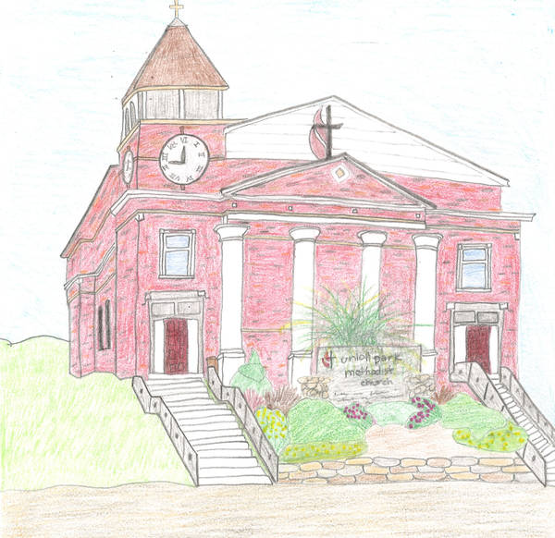

Sophia Johnson - Des Moines - "Des Moines Art Center"
Central Iowa Winner (4-6)

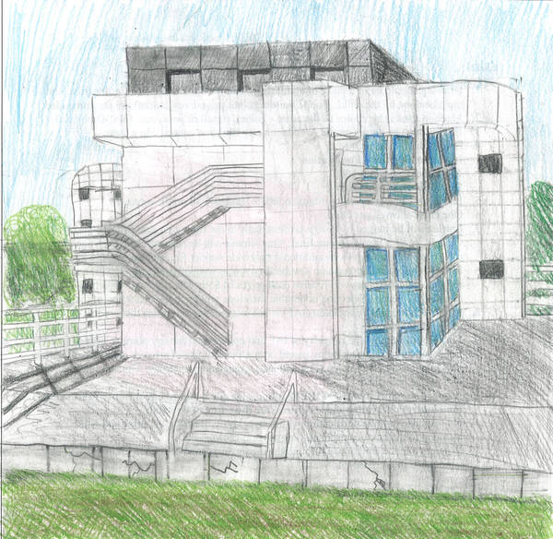

Zachary Jacob - Des Moines - "Sculpture Garden"
Grade 5

Mark Your Calendar with These
IMPORTANT DATES
2014-15

Orchestra Concert
Wednesday, June 3
12:00 Noon
Central Campus Auditorium

Field Day
Tuesday, June 9
Raindate: Thursday, June 11
Brody Middle School

Celebration Conferences
Friday, June 12
School remains in session for student-led conferences; No classes

Piano Recital
Monday, June 15
6:30pm
Central Campus Auditorium

Fifth Grade Recognition
Friday, June 19
6:00 pm
Central Campus Auditorium

All School Sing
Monday, June 22
8:30am
CC Auditorium

Last Day of School
Monday, June 22
1:30pm Dismissal

Issues of the Downtown School Dispatch will be sent electronically, unless there is
a request for a paper copy.
Check for regular updates on our web site:
http://downtownschool.dmschools.org

